**User manual for BT Stim**

**Description of BT STIM**  
  
BT Stim is a complement to the Motionstim 8 device that facilitates communication between the user and the MotionStim8. Communication can be done in 2 ways, from a serial terminal by computer or by a Bluetooth terminal through any device that has Bluetooth with the ability to send ASCII characters.

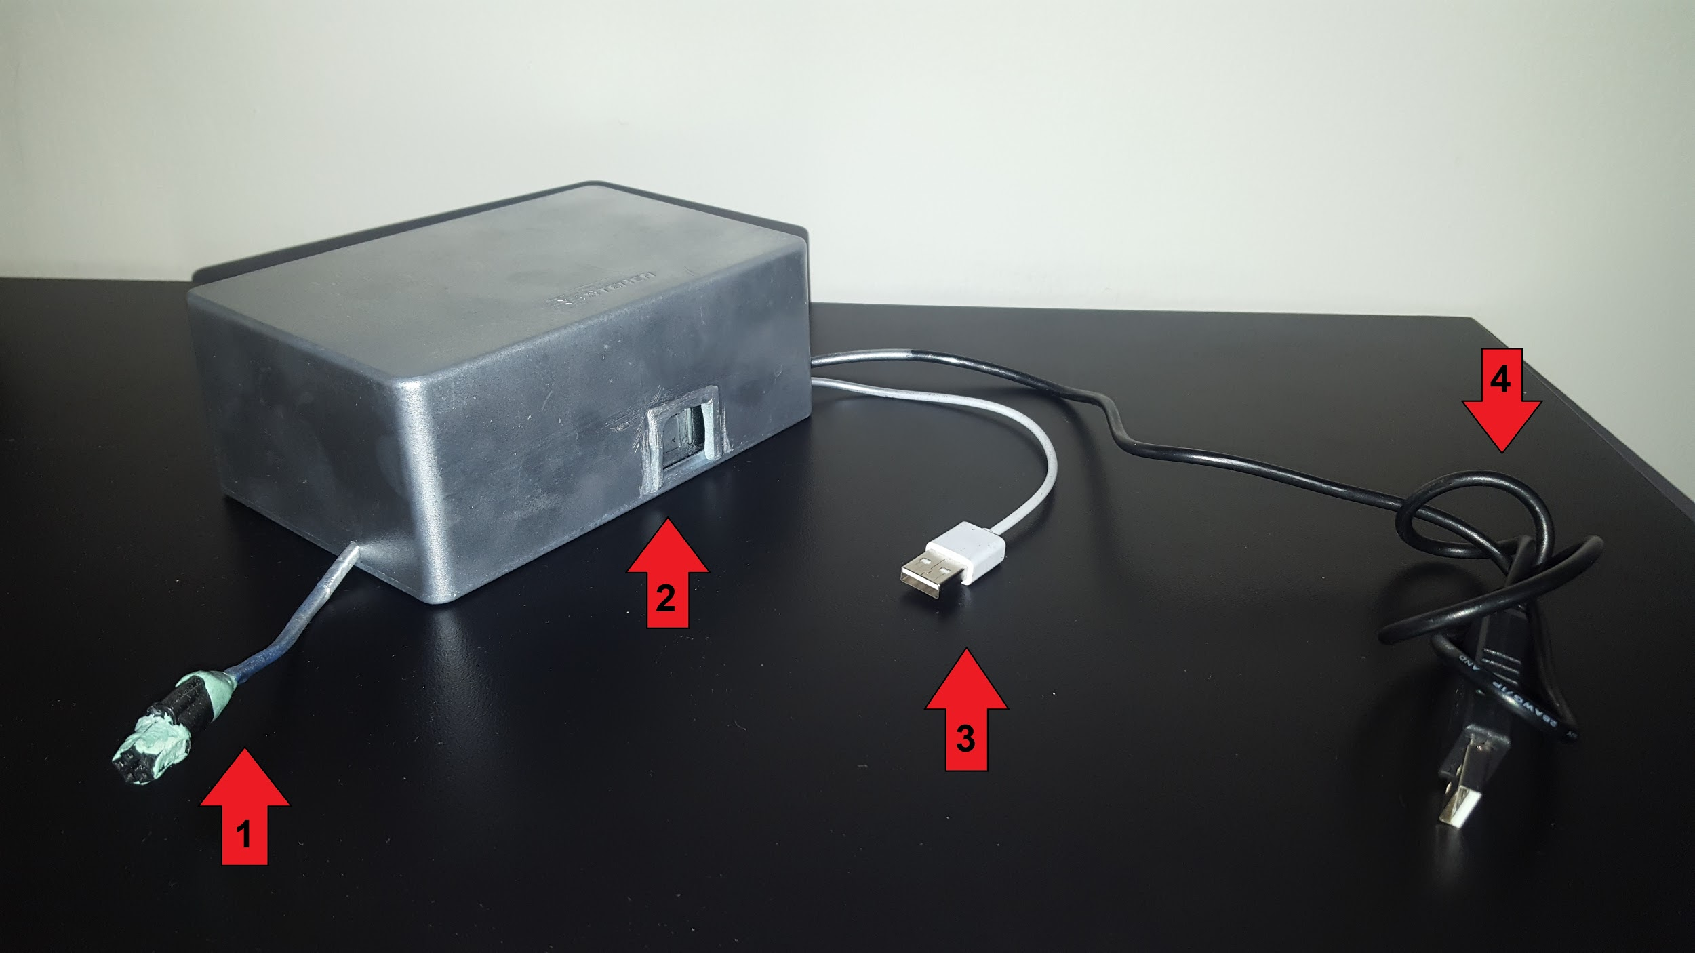

1. Connector to Motionstim 8
2. Power button
3. BT Stim Charger
4. Serial BT Stim connector

**Installation of BT Stim and electrodes**  
  
For BT Stim to be attached to the Motionstim8, it must be connected to the box that is included, for this, the blue cable must be connected to it so that the left side of the setoff that has the connector is aligned with the white line of the entrance of the box. For reference, the following images are shown:

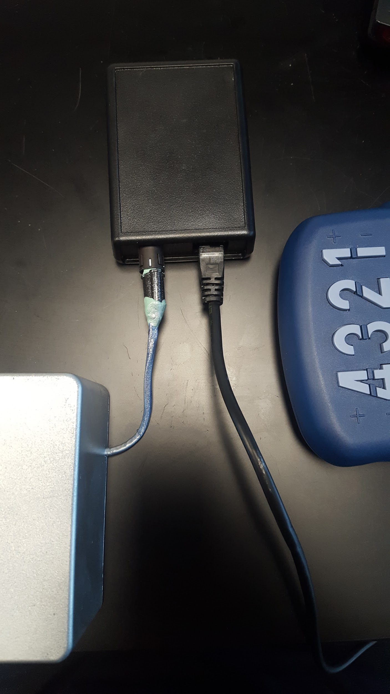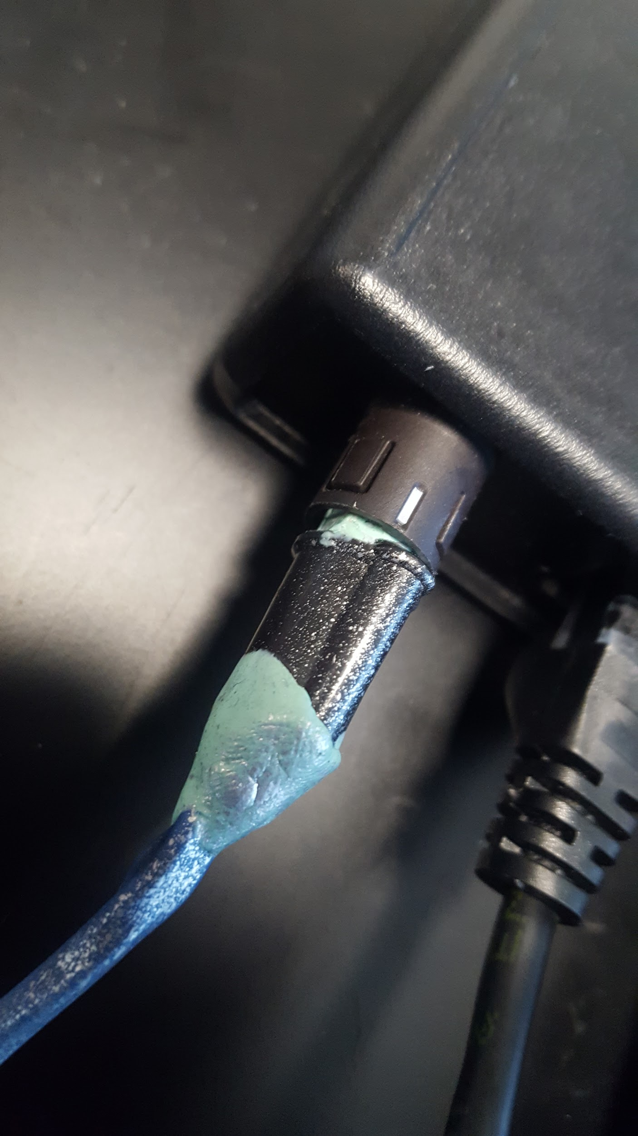

To turn on BT Stim press the button in the front, to verify that the device has charge, you must ensure that the LED next to the power button is blue.

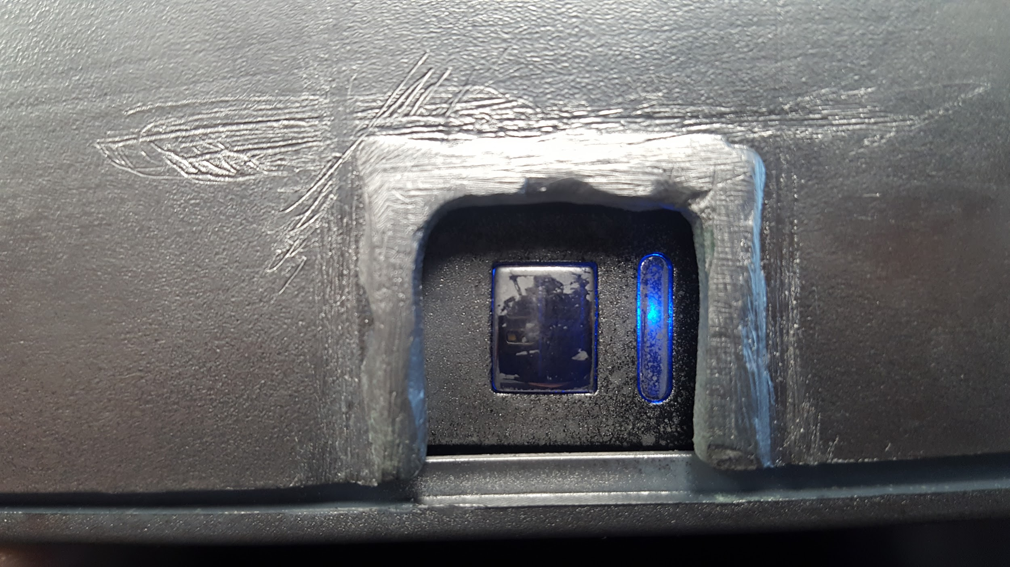

To be able to communicate in a Serial Way with the computer, connect the black cable (4) to any USB port on your computer. To work correctly you must install the correct drivers on your computer and in the properties the necessary Baud rate is 38400.

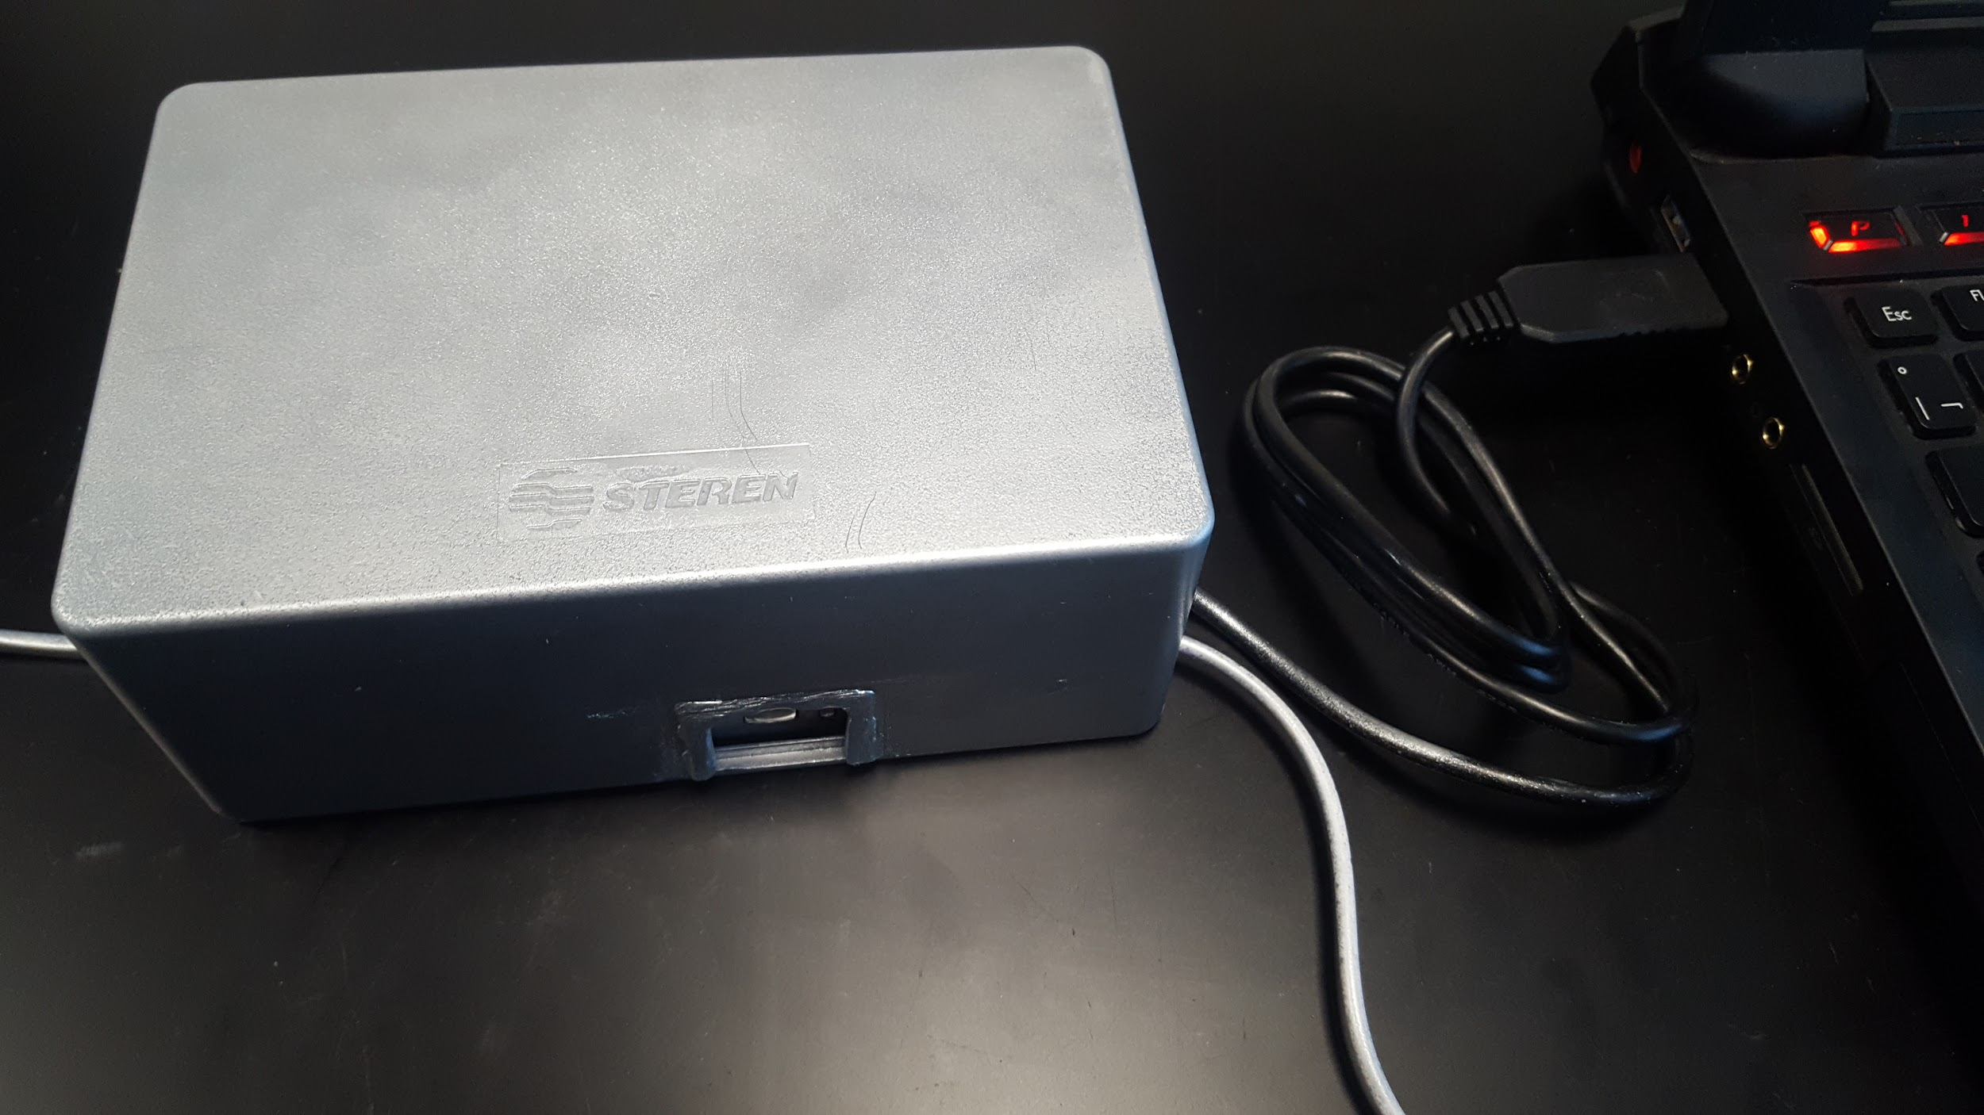

To recharge the battery of the device you have the option to connect it to a computer or use an adapter to charge it with a plug. To verify that the device is charging, you should check that the LED next to the power button is red.

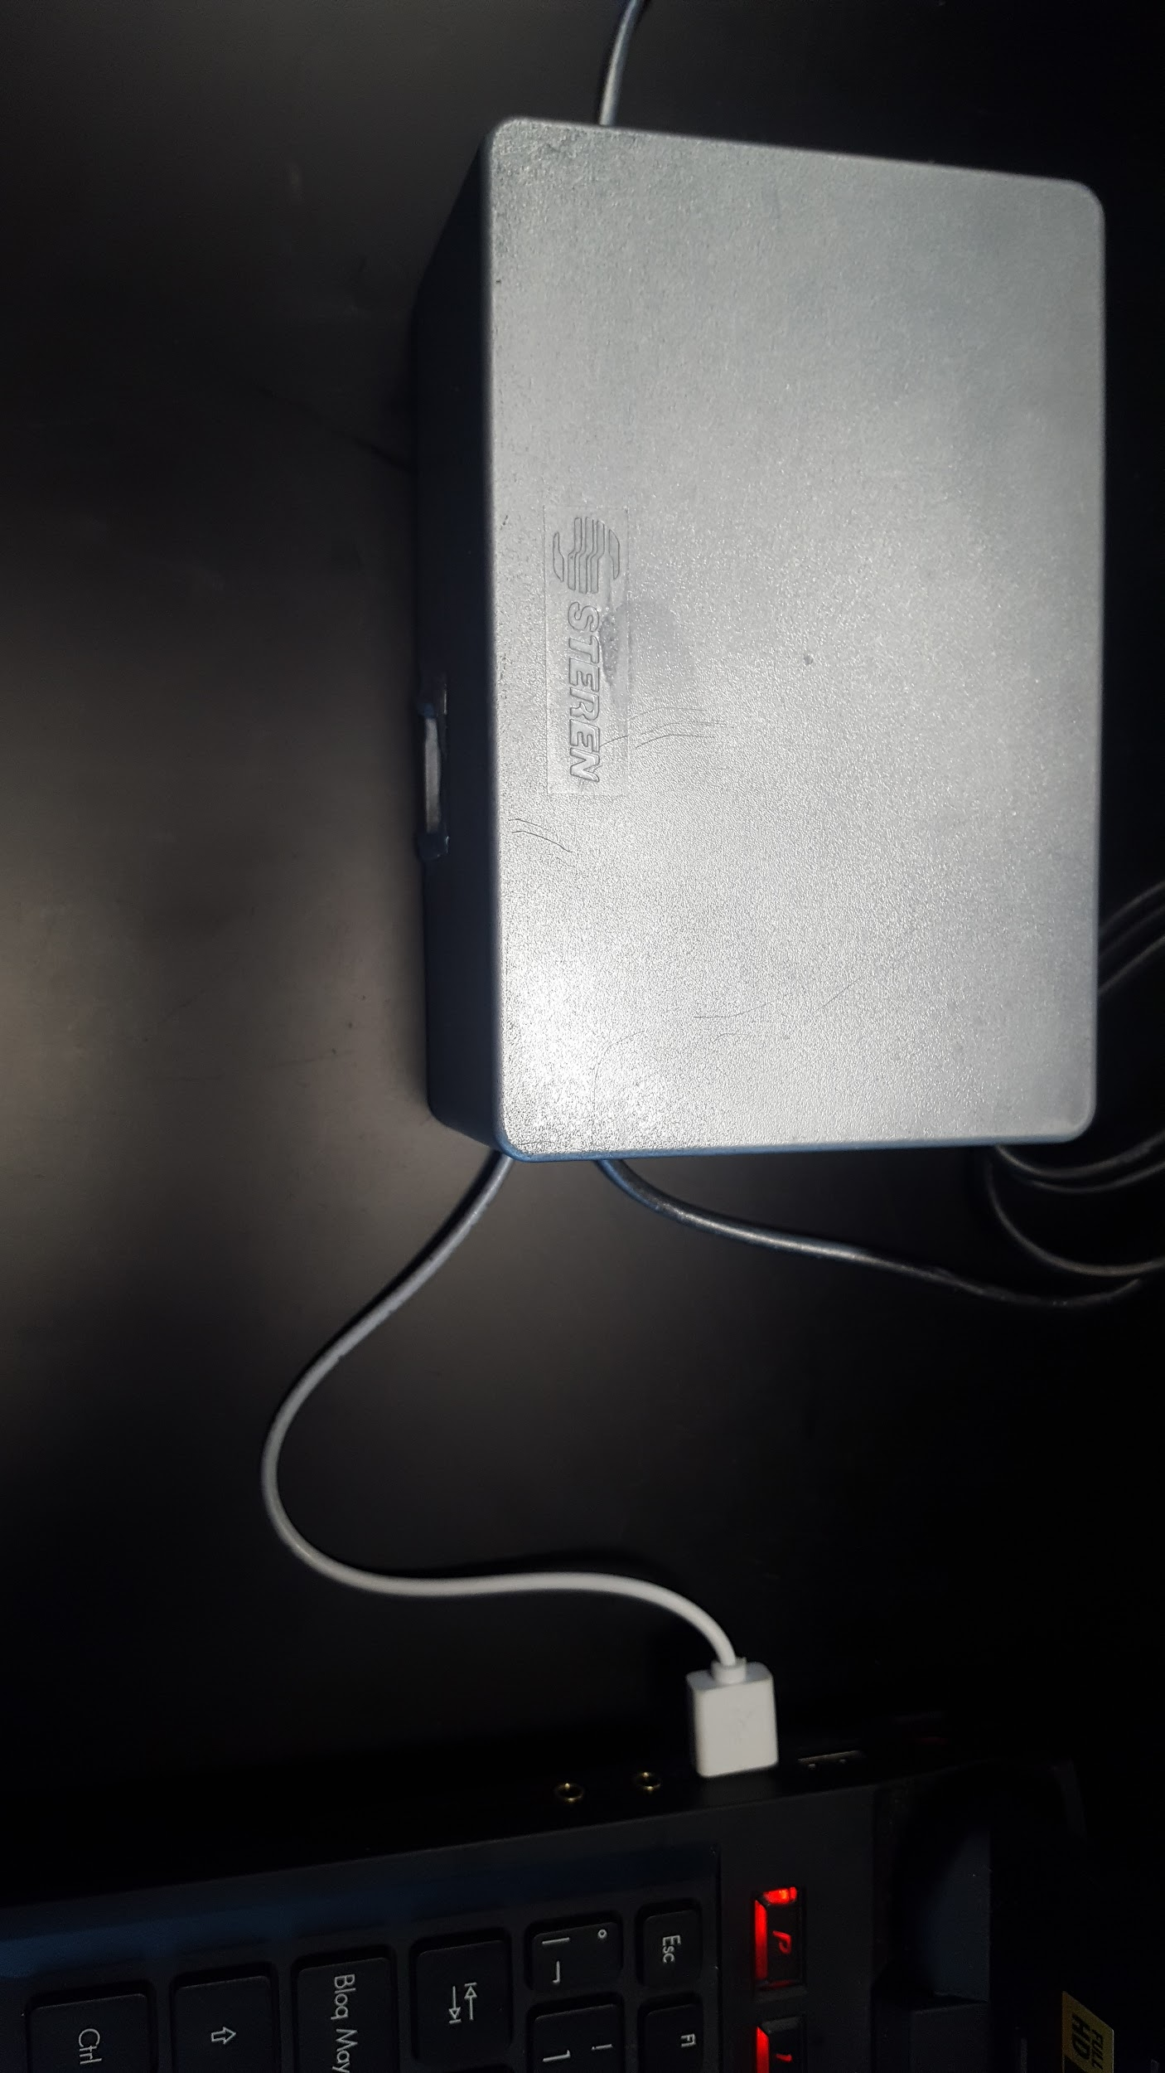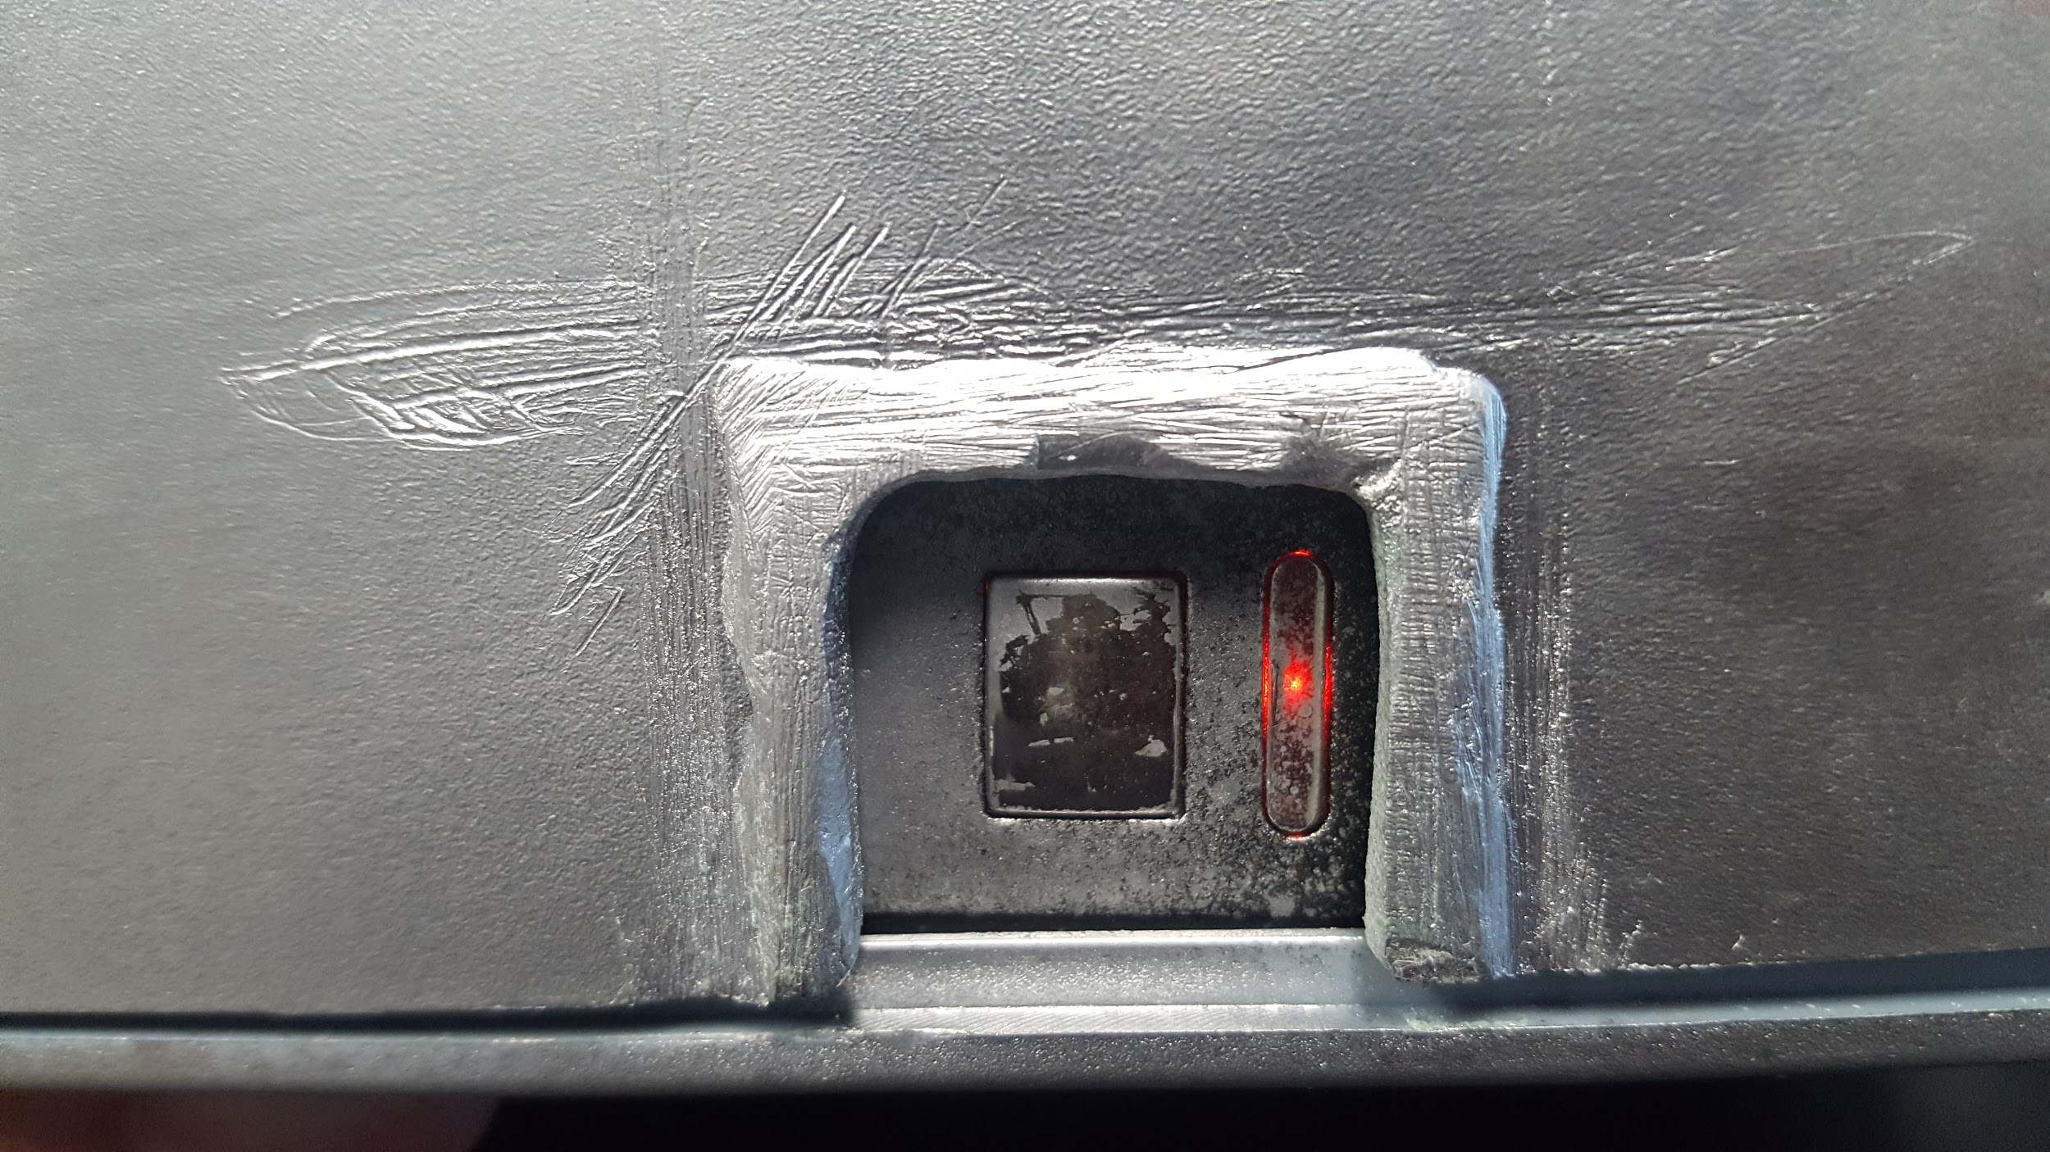

**Positioning of electrodes according to routine**

1) Closing hand.

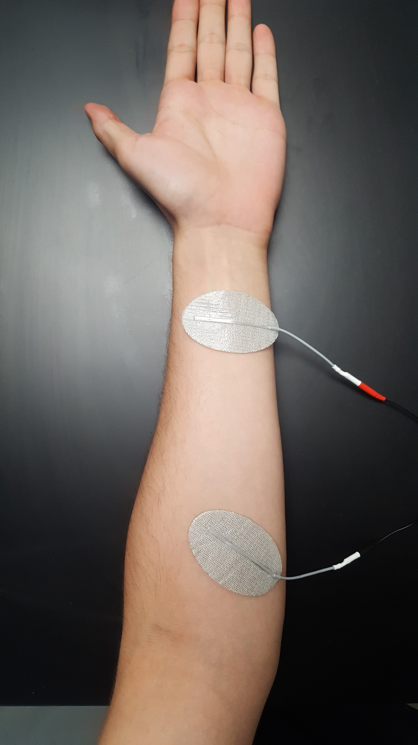

2) Wrist Extension.

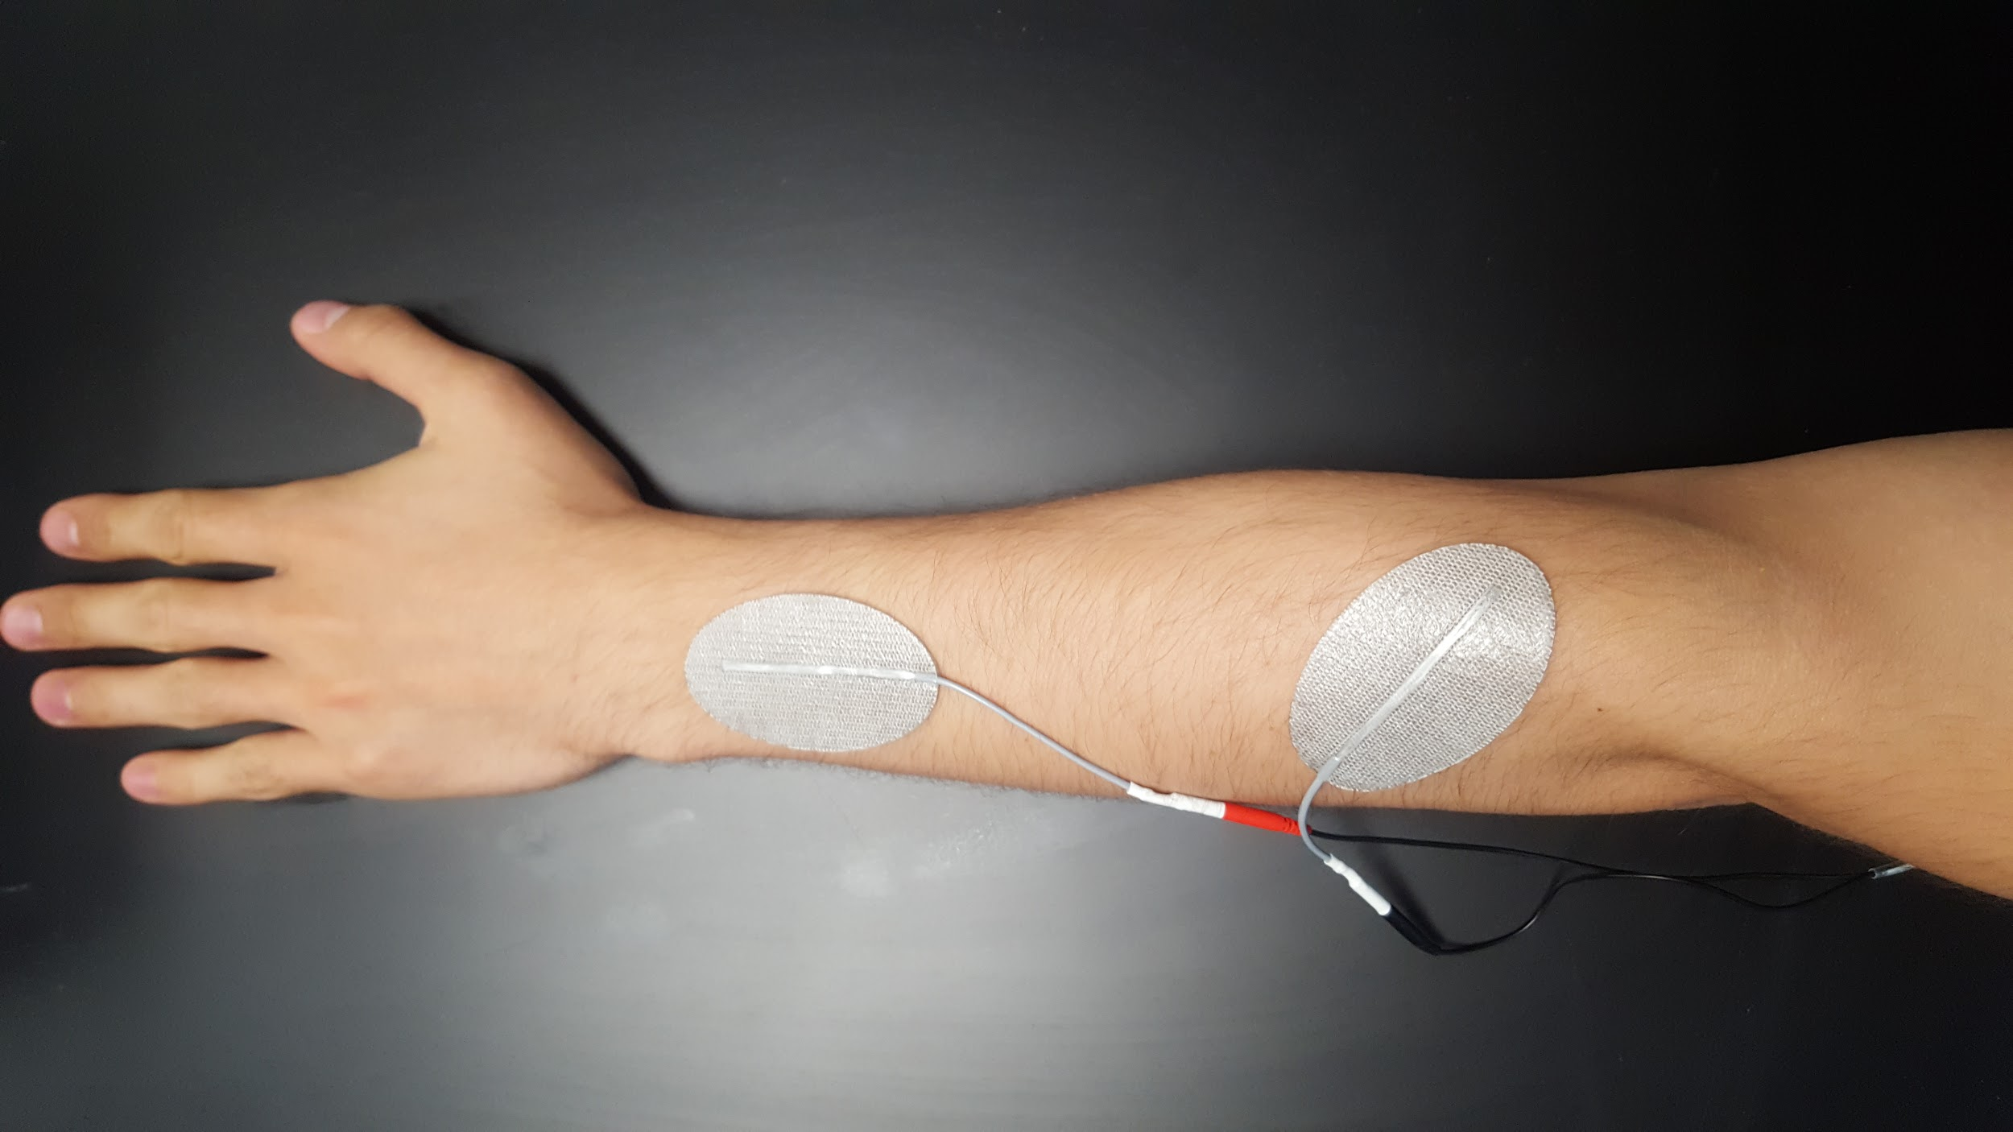

3) Radial Deviation.

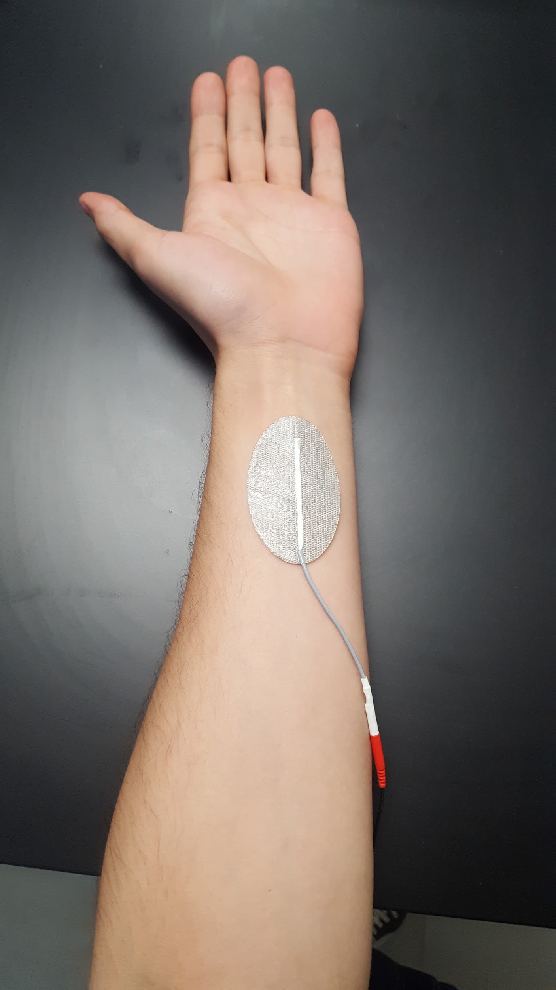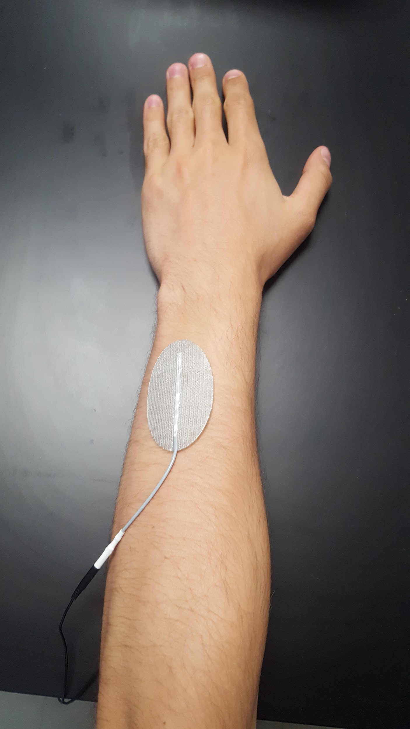

**Processes to use BT Stim**  
  
To be able to use BT Stim by Bluetooth you must connect with your cell phone. The bluetooth receptor is called MS8 and the password of the receptor is 2326. Once connected to the device either by Bluetooth or serial communication, you need to write the following words to perform each routine:

|  |  |
| --- | --- |
| Word | Routine |
| Derecha1 | Closing hand for right arm. |
| Derecha2 | Wrist extension for right arm. |
| Derecha3 | Radial deviation for right arm. |
| Izquierda1 | Closing hand for left arm |
| Izquierda2 | Wrist extension for left arm. |
| Izquierda3 | Radial deviation for left arm. |

To make it work you must make sure that when you send the command you must also send the carriage return and line feed (CR + LF).